**Data Engineering Graphs & Plots**

**Task 2.I Numeric Results & Graph:**

Figure 1: North Lane Speed DDS ReportA graph of different colored bars

Description automatically generated

Figure : North Lane Speed DDS Graph

**Task 2.II Numeric Results & Graph:**

Figure : South Lane Speed DDS Report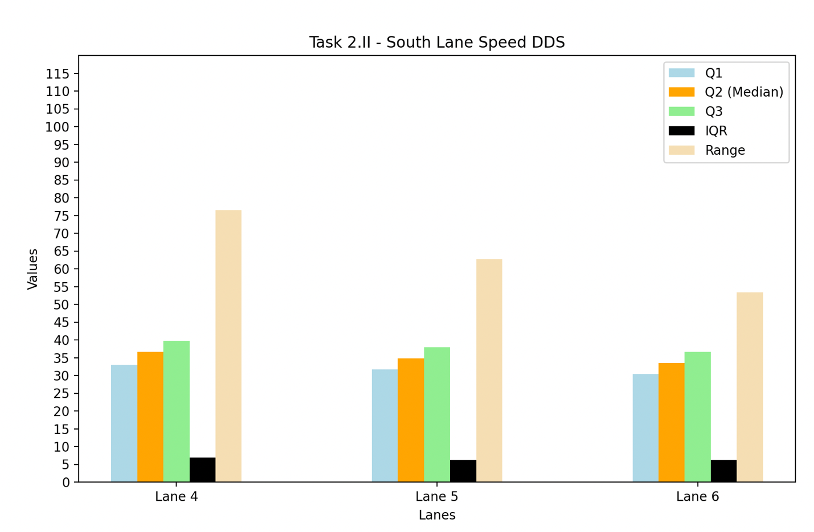

Figure : South Lane Speed DDS Graph

**Task 2.III Numeric Results & Graph:**

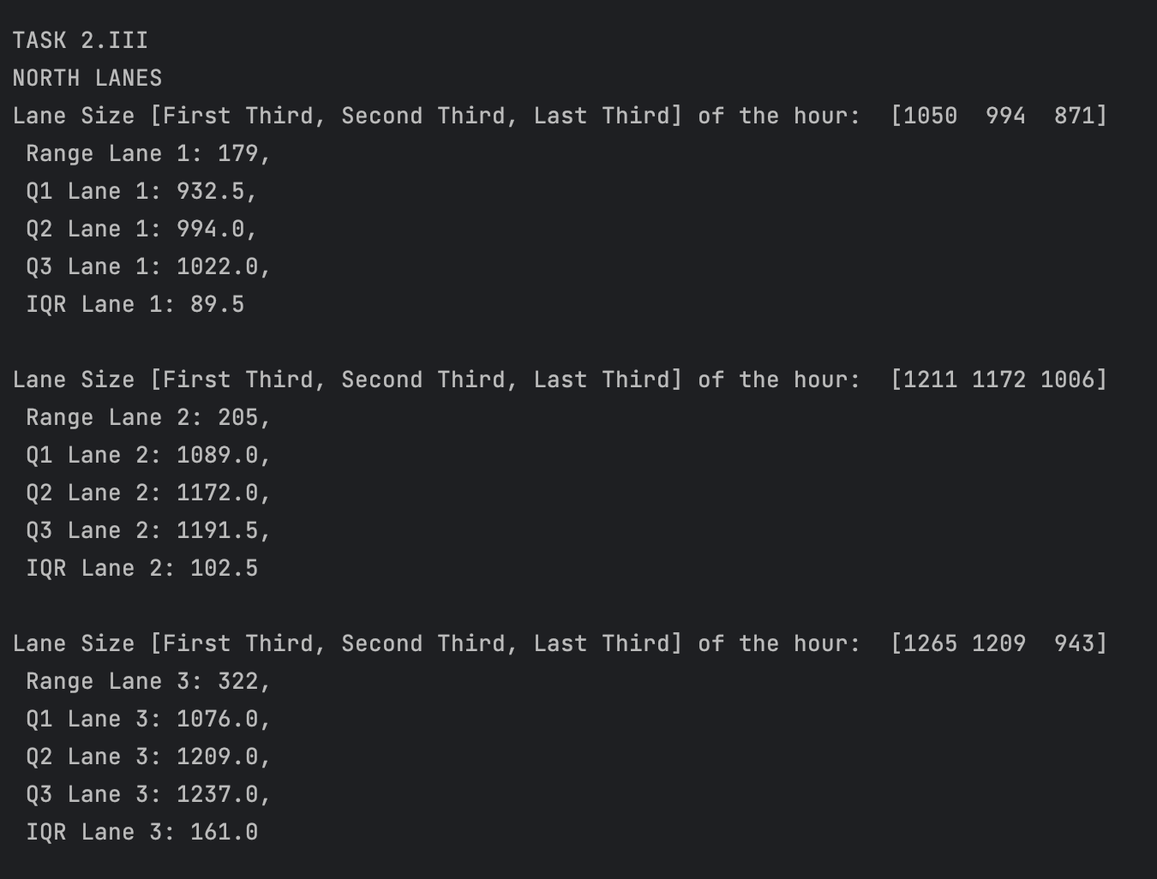

Figure : Traffic Volume of North Lanes DDS

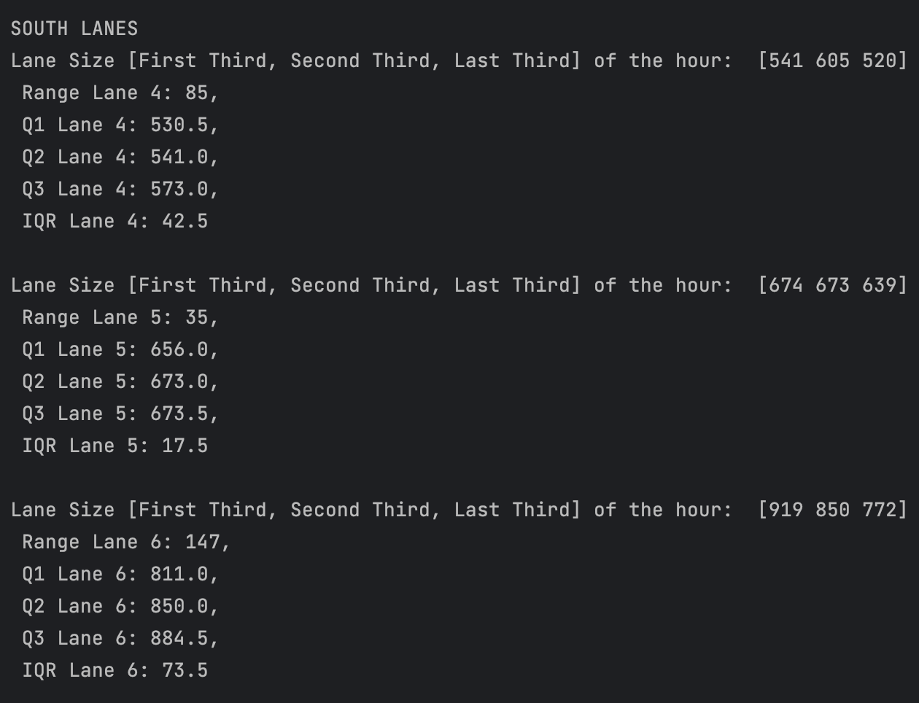

Figure : Traffic Volume of South Lanes DDS

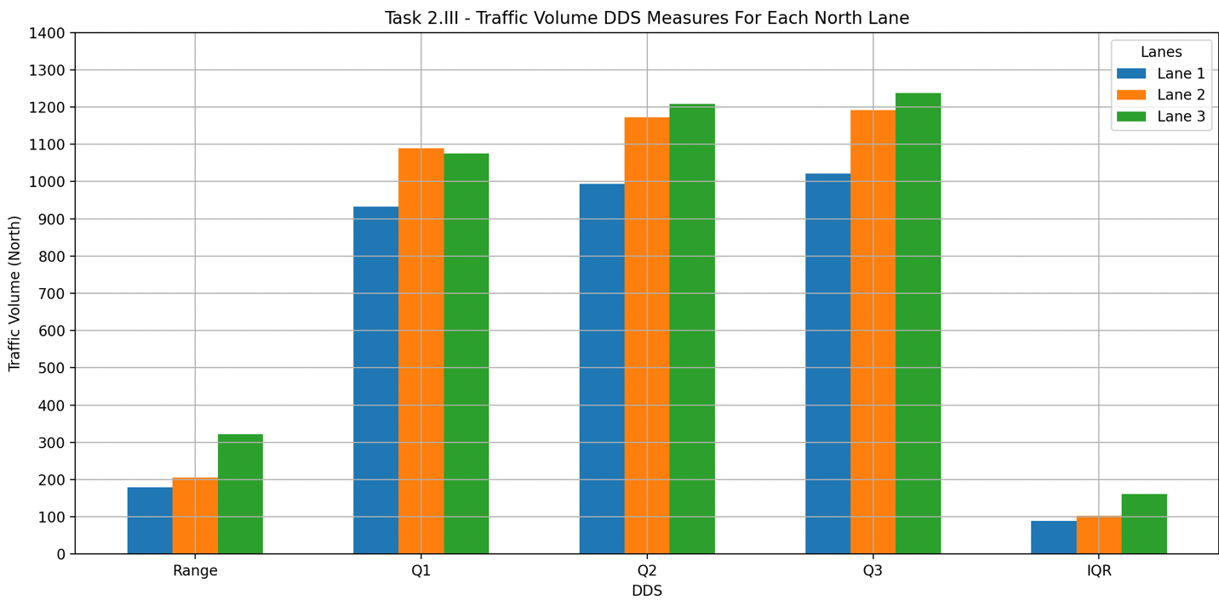Figure : North Lanes Traffic Volume Time Interval Tuesday

Figure : South Lanes Traffic Volume Time Interval Tuesday

**Task 3.I Numeric Results & Graph:**

Figure 9: Tuesday Hour Traffic Volume + Average Per Hour

Figure : Friday Hour Traffic Volume + Average Per Hour

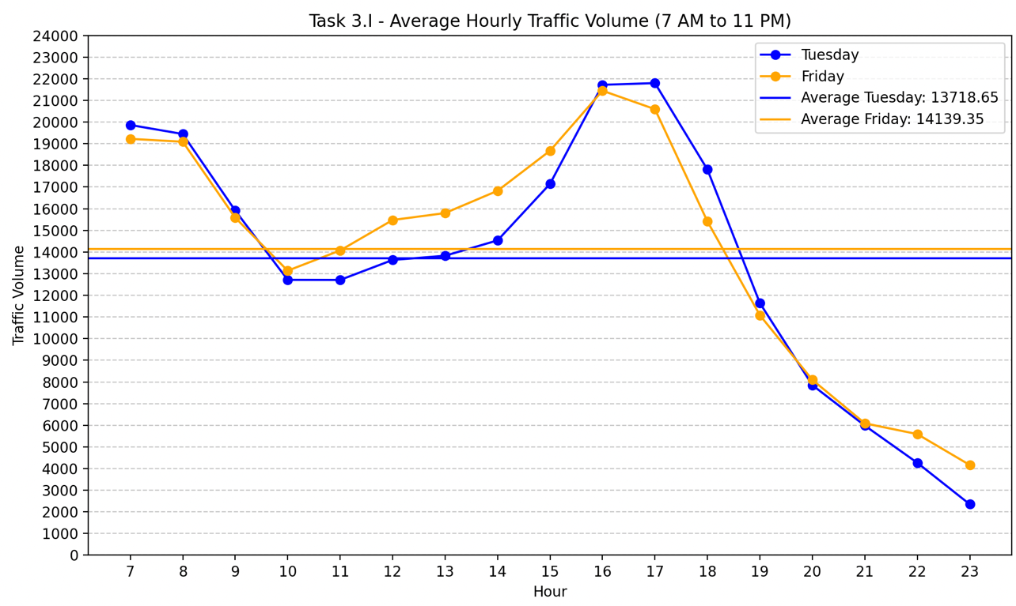

Figure : Average Per Hour Plot Friday + Tuesday